### **Task: Authentication**

Strong password are very important, weak passwords can be easily guessed (those that aren’t hard to guess or common words).

### **Password Guidelines**

* Use a different password for each online account. Using the same password for more than one account risks multiple exposures if one site you use is hacked.
* Do not use people's names or special dates as passwords. Avoid any combination of characters that friends, or acquaintances can easily guess. For example, a password such as "Nov19" for an ANZ Online Bank account is not a strong password.
* Use syllables or acronyms. Avoid using complete words that appear in any dictionary regardless of the language. One option is to start with the first letters of a familiar phrase. For example, "Mary had a little cat" becomes "Mhalc," which could be part of a secure password.
* Use a combination of upper- and lower-case letters, numbers, and punctuation/special characters, such as &^$#.
* Change your password regularly, especially your financial and email accounts. Intuit contacts you via email if there is any activity you need to know about on your account.

### **Keep your password safe**

The second step in protecting your accounts is to keep you keep your password safe:

* Keep it to yourself. Do not share your password with others. You never know what the future will bring in relationships or coworkers, so do not give your password out – to anyone.
* Keep your passwords safe. Don’t write them down in a place where others can find them. There are programs available where you can securely store your passwords.

### **Username Guidelines**

Your username is the key to your online identity on many sites.

Pick a username that you can remember. If you create a name that's unusual for you, you may not remember it the next time you log on.

1. Make it simple. Unlike your password, avoid using too many symbols or upper- and lower-case letters. It'll slow you down when you type it in.
2. Never use a social security number as a username or password. Social security numbers may be hard to guess and easy to remember, but they could give malicious fraudsters a coveted piece of personal information that can be exploited.
3. Decide whether you want to remain anonymous. On some community sites, your username will appear next to each of your public posts.
4. Slow down. If you choose a username in haste, you may not be able to change it later. This is especially important for accounts that stay with you for years.

**Validation email:**

The correct email format must be entered to be able to register the email address.

Email address must contain @ on the address to be able to register otherwise it will show an error message.

### **Super User and Group created**

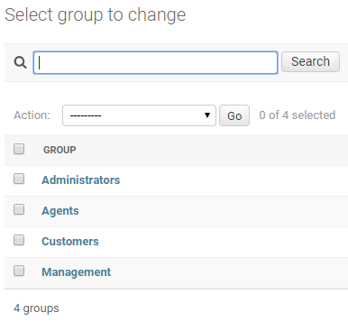

**Company departments:**

• **Administrators** – look after the web site. They should have permissions to add, modify and delete records from all the tables and manage website users and permissions

• **Agents** – they provide their personal information and information on the tours they conduct. They should have permissions to add a tour and modify tours that they conduct. Note: Agents should only be able to modify their own tours.

• **Management** – They should be able to see all the tour and agent information. They should also be able to remove agents from the list and modify all the tour information.

• **Customers** – They should be able just to see the agent names, tour available and durations.

### **Users added**

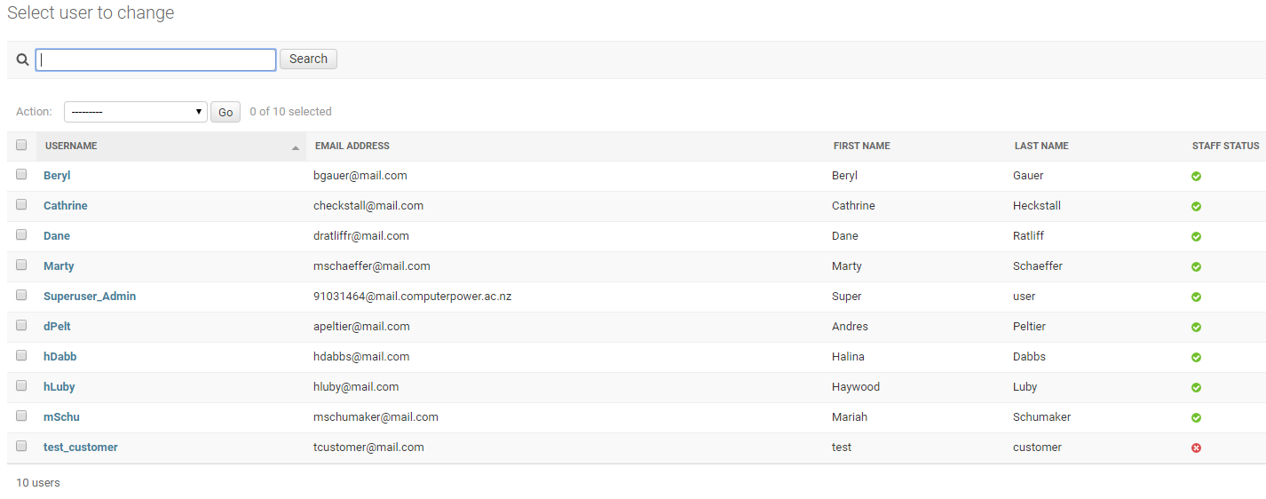

Assigned users to the groups created.

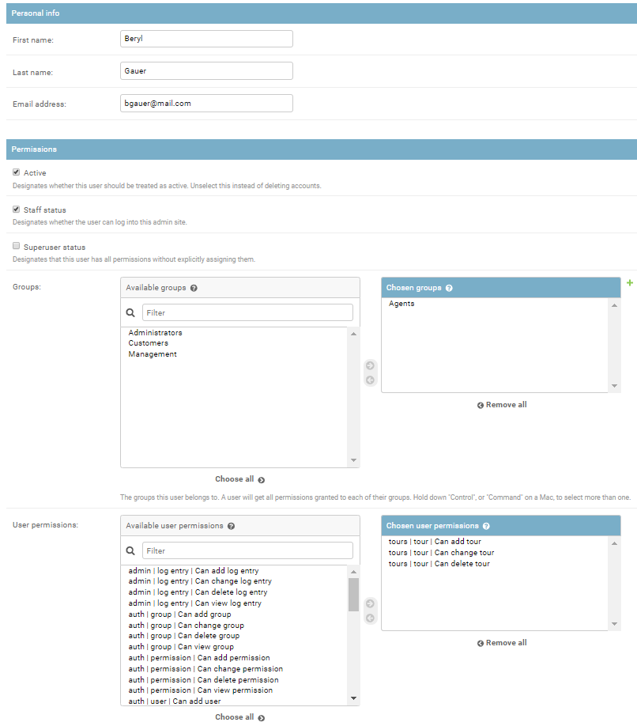

### **Users Information**

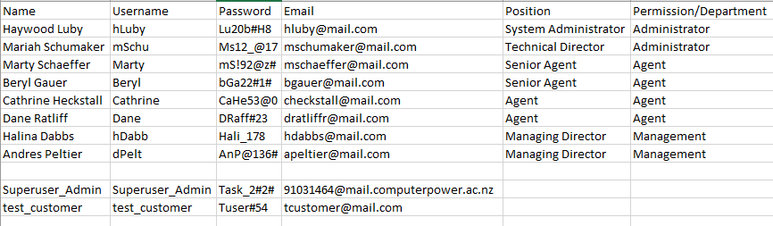

* **Authentication views including appropriate website templates completed and tested.**

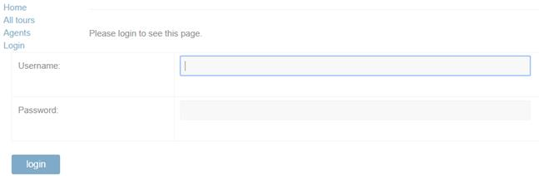

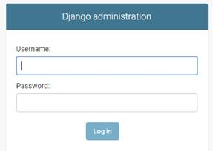



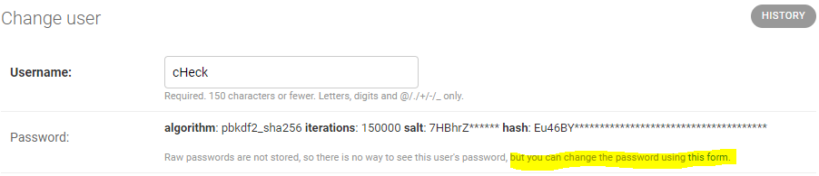

### **Task: Authorisation**

* User and group permissions setter as per the requirements.

Administrator Permissions

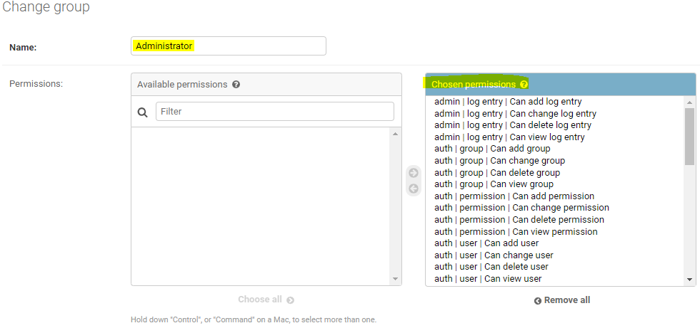

Agents Permissions

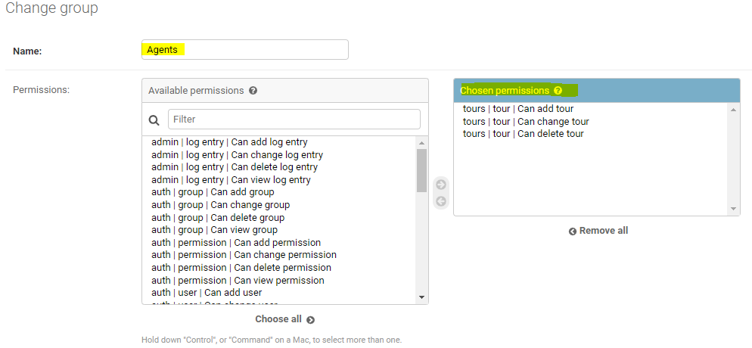

Management Permissions

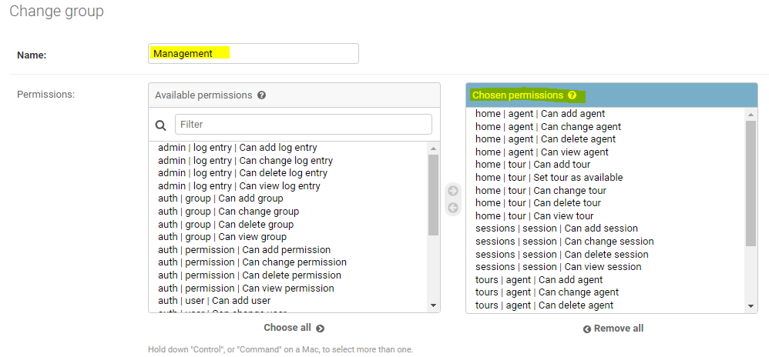

Customers Permissions

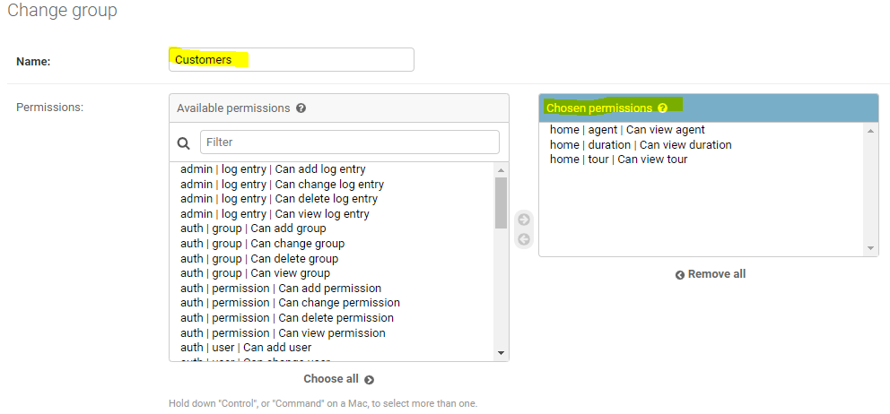

Test Log

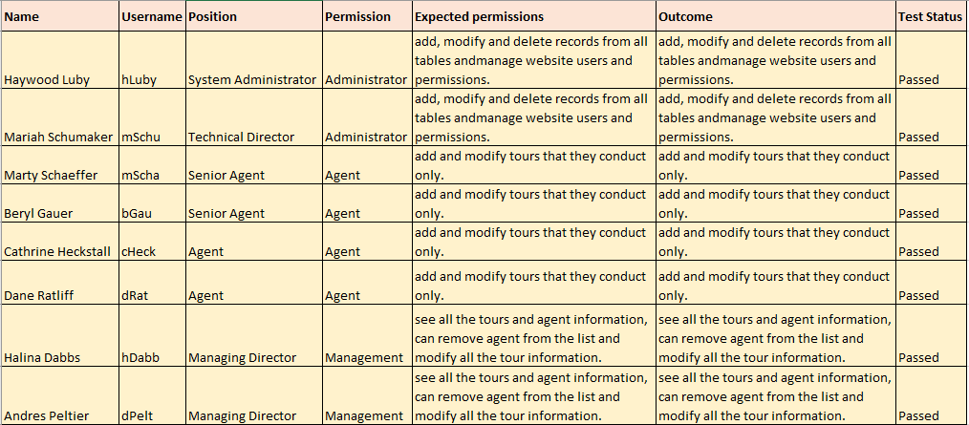

* Web page: home/tours_by_agent – listing all the tours in the system for the specific agent that is conducting the tour created.

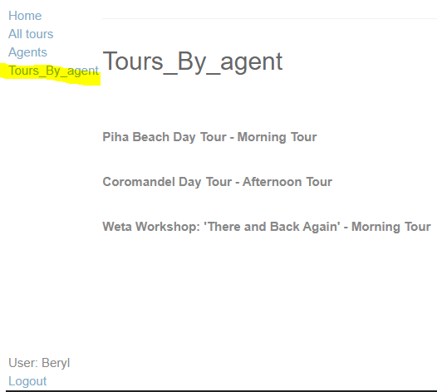

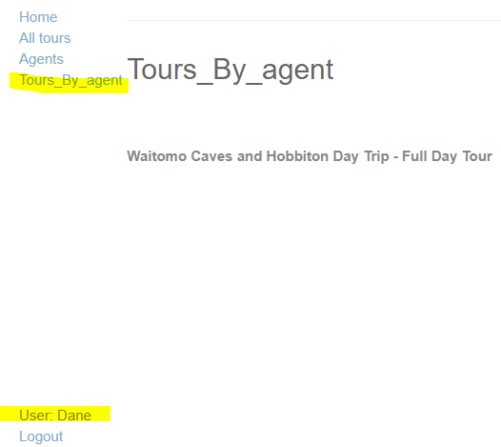

### **Task: Validation**

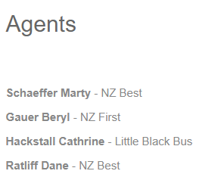 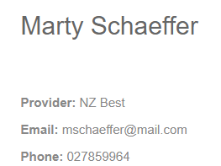

**Validation for email address.**

